Project - Milestone 1 Progress Report

Myles Lefkovitz  
[mlefkovitz@gatech.edu](mailto:mlefkovitz@gatech.edu)

# Summary of Activities

**Scheduled Work:**

Week 8

1. Research ITS and SRS platforms (4 hours)
2. Set up a local development environment as a fork of an open source SRS environment (4 hours)
3. Read through the documentation and add data to the tool (4 hours)

Week 9

1. Add initial learning material to the tool: add material across 3 categories (3 types of right/wrong pairs with corresponding mnemonics) (5 hours)
2. Test the software (2 hours)
3. Document the implementation plan for a selected ITS open source platform (4 hours)

Week 10

1. Implement the ITS within the existing flashcard system (6 hours)
2. Create students (0.5 hours)
3. Create training plans for students (1.5 hours)
4. Prepare Milestone 1 Progress Report with low-fidelity prototypes (drawn diagrams of the intended user interfaces and interactions) (2 hours)

**Successfully Completed Work:**

As discussed with my mentor, I ran into a number of implementation issues during the first two weeks of this project. I have worked through most of them, but am still behind vs the scheduled work efforts.

Thus far, I have successfully implemented a learning (SRS) platform. I selected “Learn With Text” after failing to successfully implement Anki and Mnemosyne, two more popular learning platforms.

After successfully implementing the platform, I was able to create learning material and test the software successfully. I added learning material in Japanese. I am familiar with basic Japanese and wanted to test how a different character set would function in the application. Initial learning material includes the two basic alphabets (Hiragana and Katakana), some basic kanji characters, some words composed of hiragana, katakana, or kanji characters (or combinations), and two basic sentences (for testing purposes).

In preparation for an implemented ITS system, I’ve created training plans for 3 students.

**Work not completed:**

Unfortunately, I haven’t been able to implement an ITS platform within the flashcard system, document an implementation plan, or create student profiles within that system.

**Lessons Learned:**

It’s apparently very challenging to run some applications from source on Windows, especially if these applications run on multiple platforms with very specific dependencies and if most of the setup instructions are designed for Linux/Mac.

# Training Plans

Below I detail the (simple) training plans I’ve created for 3 students. The language content added to the system is in Japanese as described above.

**Student 1:**

This student gets the most basic hiragana characters あ、い、う、え、お (a, i, u, e, o) correct, but is incorrect on the next set of hiragana characters: か、き、く、け、こ (ka, ki, ku, ke, ko).

The idea is that the ITS should suggest mnemonics for each of the incorrectly answered characters (I’ll have to make them up).

**Student 2:**

This student gets all of the katakana characters correct except for one: メ (me)

The student then tries to learn words spelled in katakana that do not contain the character. The system should not interefere.

The student then tries to learn a word spelled in katakana アメリカ (America) that does contain the character. If the ITS’s dependency-based teaching system is implemented correctly, the intelligent teacher should prevent or warn the student against learning more complex words that build upon fundamental learnings that the student hasn’t mastered.

**Student 3:**

This student gets all of the hiragana characters correct. This student then tries to learn kanji characters. The student gets some kanji characters incorrect. The ITS should suggests mnemonics for the incorrectly answered kanji characters.

The student then tries to learn words using the kanji characters. The ITS should warn/prevent the student from learning these words before the kanji characters have been mastered.

# User Flow Diagrams

Below are 5 low-fidelity prototype design pages indicating the design of the application.

Interaction with the application begins with the “Home Page” below:

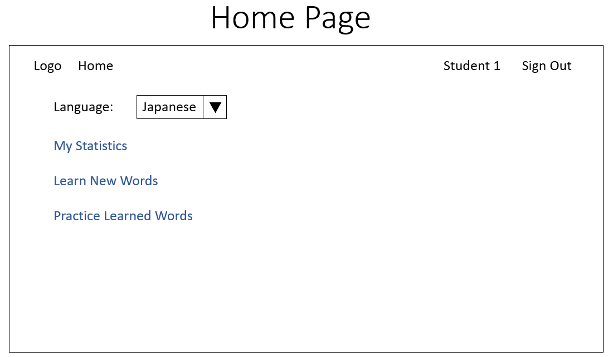

From this page, the user is able to select their language (for learning, the menu language is always English). Log out (or in, if not logged in). View their user statistics (via “My Statistics”), learn new words (via “Learn New Words”), or practice learned words (via “Practice Learned Words”).

The “Learn New Words Page” below is accessed by clicking “Learn New Words” on the home page above.

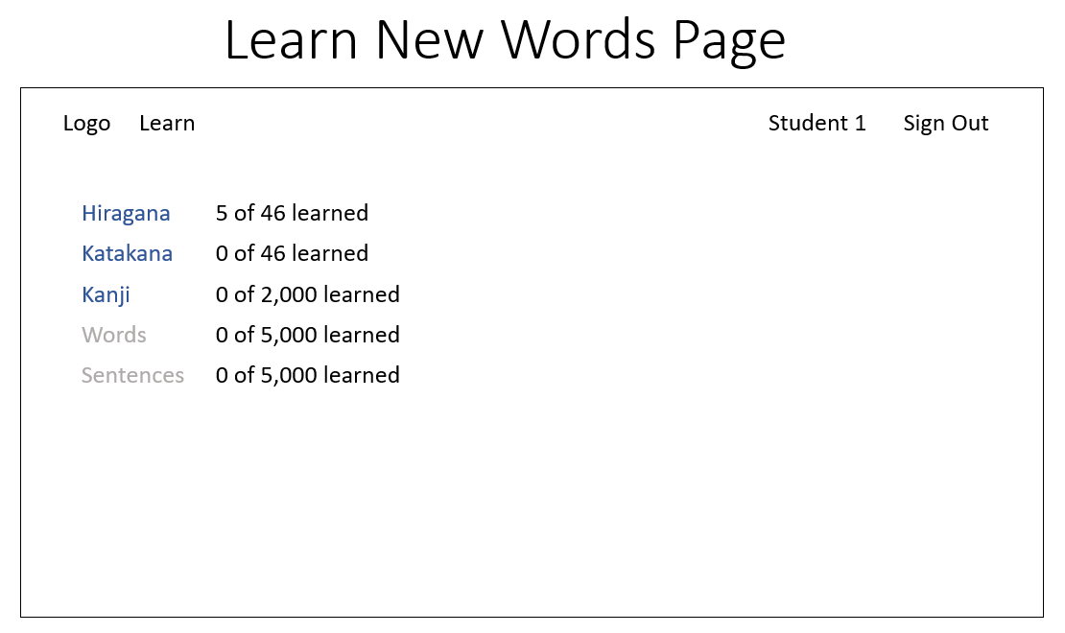

On this page the user can select the category of words they want to learn (available categories are shown in blue and unavailable categories are shown in grey) or return to the home page by clicking the logo in the top left.

Clicking one of the blue links in the above page brings up the second layer of the “Learn New Words Page”.

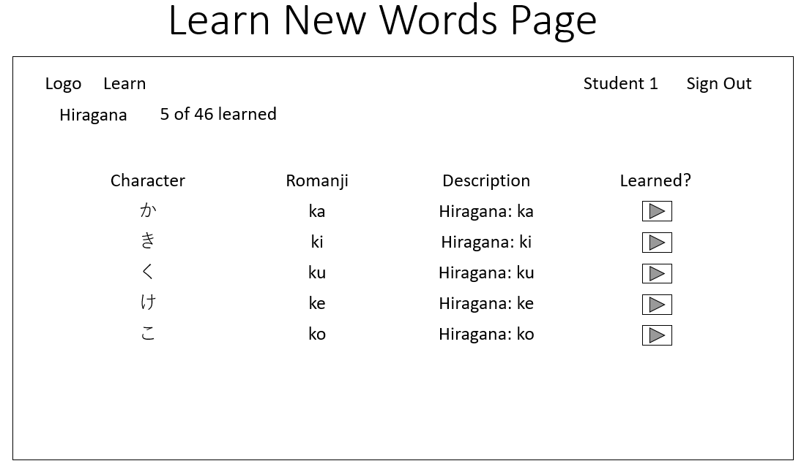

This page shows up to 5 characters for memorization. The user confirmed that they have memorized the word by clicking the button in the “Learned?” column. After all 5 buttons have been clicked, a new set of words appears. The user can exit the learning page at any time by clicking the logo in the top left to return to the home page.

The “Practice Learned Words” page below is accessed via the home page by clicking on the “Practice Learned Words” link.

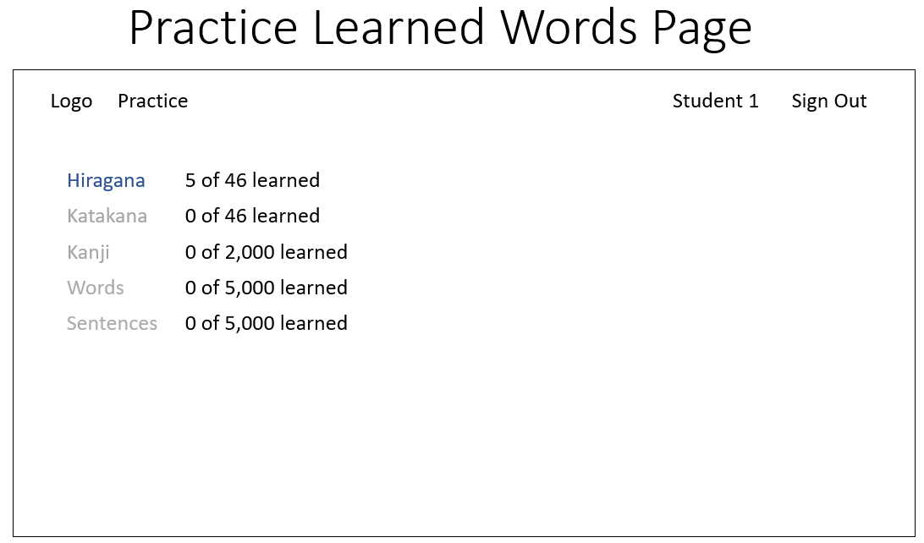

On this page the user can select the category of words they want to practice (available categories are shown in blue and unavailable categories are shown in grey) or return to the home page by clicking the logo in the top left.

Clicking one of the blue links in the above page brings up the second layer of the “Practice Learned Words Page”.

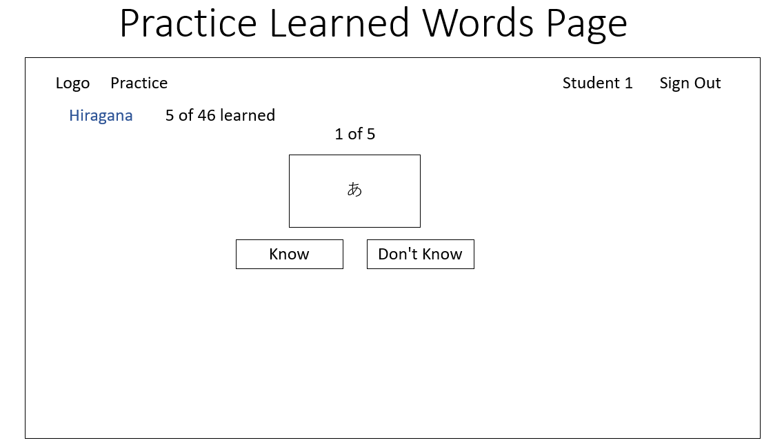

Practicing learned words allows the user to train their memory. A user is given a flash card containing a word in the category they are practicing and are asked if they know it. The user can see the definition and romanization of the word if they click ‘Don’t Know’. How frequently the ‘Know’ and ‘Don’t Know’ button have been pressed affects the SRS algorithm, which determines the level of mastery the user has over a particular word and how frequently it is presented in practice.